LAB#01:

INTRODUCTION TO IDEs.

**LAB # 01**

Lab Task:

1. Use Visual Studio C++ 2022 to create a project named, task1 and then add a .CPP file named, First to this project. Now add given piece of code to file task1 and compile this file. Execute this file afterwards and check the output of your program

Source Code:

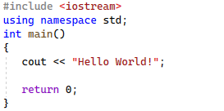

Output:

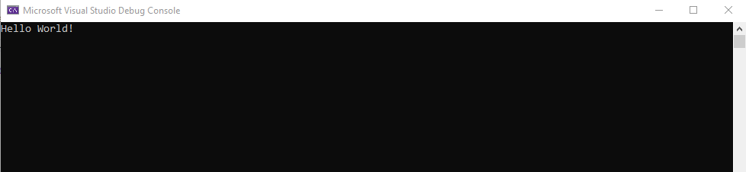

1. Use Visual Studio C++ 2022 to create a project named, task2 and then add a .CPP file named, First to this project. Now add given piece of code to file task2 and compile this file. Execute this file afterwards and check the output of your program

Source Code:

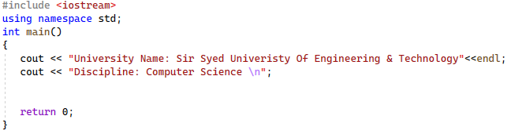

Output:

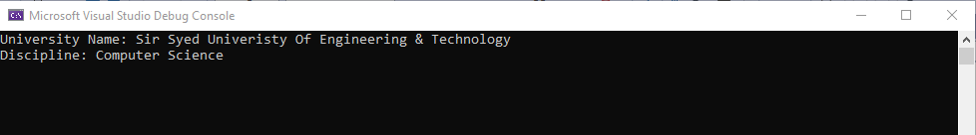

1. What is the output from the following C++ code fragment?

Source Code:

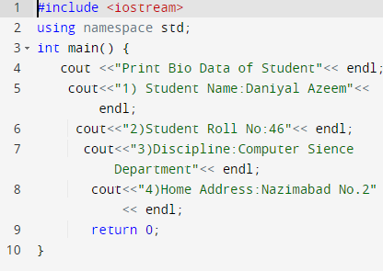

Output:

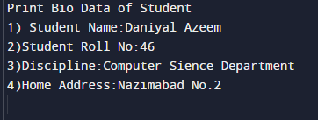

1. What is the output from the following C++ code fragment?

Source Code:

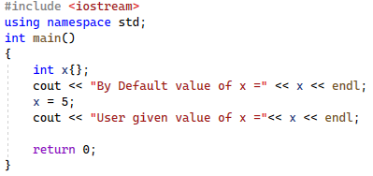

Output:

